**CHAPTER THREE**

**SYSTEM ANALYSIS AND DESIGN**

**3.0 INTRODUCTION**

This chapter discuss on the system methodology and the system analysis of the system.

**3.1 METHODOLOGY**

The methodology used for the development of this project is agile software development process.

**3.2** **ANALYSIS**

**3.2.1 ANALYSIS OF THE EXISTING SYSTEM**

The existing system is a manual system, were by the client must come to the company to register using paper and pen and they also come to the company to check whether they as being register for particular project or not.

**3.2.2 ANALYSIS OF THE PROPOSED SYSTEM**

The proposed system is an online system that will be able to keep the company employee information and the client information that register for a particular project and also to register for the equipment available in the company and the client can make a request for any type of the equipment they need for the extraction of the Gold.

**3.3 SYSTEM DESIGN**

The system is divided into three section, Admin, Client and Employee sections. Each and every part have their own functionality.

**3.3.1 SYSTEM FUNCTIONALITY**

**Admin:** Employee Registration, Update, Login and Logout.

**Employee:** Client Registration, Register Project for client, Update, Register Equipment, Reports and Login and Logout.

**Client:** Request for Equipment, Update,Login and Logout and Reports.

**3.3.2 USE CASE**

**3.3.2.1 USE CASE OF THE SYSTEM**



**3.3.3 ACTIVITY DIAGRAM OF THE STUDY**

**3.3.3.1 ADMIN ACTIVITY DIAGRAM**

Login form

View Reports

View Admin Interface

Validity

No

Start

End

Verify User

Yes

Employee Registration

Update

Display form

Fill the form

Display form

Fill the form

Validity

No

No

Yes

Yes

Submit

Update Info

**3.3.3.1 EMPLOYEE ACTIVITY DIAGRAM**

Equipment Registration

Login form

View Reports

View Employee Interface

Validity

No

Start

End

Verify User

Yes

Client Registration

Update

Display form

Fill the form

Display form

Fill the form

Validity

No

No

Yes

Yes

Submit

Update Info

**3.3.3.1 CLIENT ACTIVITY DIAGRAM**

Login form

View Reports

View Client Interface

Validity

No

Start

End

Verify User

Yes

Equipment Registration

Update

Display form

Fill the form

Display form

Fill the form

Validity

No

No

Yes

Yes

Submit

Update Info

**3.4 SOFTWARE REQUIREMENT**

Front end tool: PHP

Backend: SQL

Operating system: Windows 10

Client Side: HTML, bootstrap

**3.5 HARDWARE REQUIREMENT**

Processor: Pentium IV and above

Processor speed: 1.4 GHz Onwards

System memory: 128 Mb minimum 256 Mb recommended

RAM: 512 MB(Minimum)

Hard disk: 80Gb

Monitor: SVGA Colour 15”

**CHAPTER FOUR**

**SYSTEM IMPLEMENTATION AND TESTING**

**4.0 SYSTEM IMPLEMENTATION**

**4.0.1 CHOICE OF THE PROGRAMMING LANGUAGE USED**

**PHP: Hypertext Preprocessor** (or simply **PHP**) is a [general-purpose programming language](https://en.wikipedia.org/wiki/General-purpose_programming_language) originally designed for [web development](https://en.wikipedia.org/wiki/Web_development). It was originally created by [Rasmus Lerdorf](https://en.wikipedia.org/wiki/Rasmus_Lerdorf) in1994 the PHP [reference implementation](https://en.wikipedia.org/wiki/Reference_implementation) is now produced by The PHP Group (PHP Group, 2008). PHP originally stood for Personal Home Page, but it now stands for the [recursive initialism](https://en.wikipedia.org/wiki/Recursive_initialism) PHP: Hypertext Preprocessor.

PHP code may be executed with a [command line interface](https://en.wikipedia.org/wiki/Command-line_interface) (CLI), embedded into [HTML](https://en.wikipedia.org/wiki/HTML) code, or it can be used in combination with various [web template systems](https://en.wikipedia.org/wiki/Web_template_system), web content management systems, and [web frameworks](https://en.wikipedia.org/wiki/Web_framework). PHP code is usually processed by a PHP [interpreter](https://en.wikipedia.org/wiki/Interpreter_(computing)) implemented as a [module](https://en.wikipedia.org/wiki/Plugin_(computing)) in a web server or as a [Common Gateway Interface](https://en.wikipedia.org/wiki/Common_Gateway_Interface) (CGI) executable. The web server combines the results of the interpreted and executed PHP code, which may be any type of data, including images, with the generated web page. PHP can be used for many programming tasks outside of the web context, such as [standalone](https://en.wikipedia.org/wiki/Computer_software) [graphical applications](https://en.wikipedia.org/wiki/Graphical_user_interface)(PHP Manual, 2008) and robotic [drone](https://en.wikipedia.org/wiki/Unmanned_aerial_vehicle) control (helicopter, 2019).

**4.1 USER MANUAL**

**SELECTING MAIN NENU OPTION**

The software developed contain a menu program from which all other modules are called the main menu consist of horizontal menu option. Any of these can be right mouse click to highlight the menu option and enter key is pressed to confirm the selection.

This chapter entails discussion on the software installation requirement operation and users guide manual.

**INSTALLATION OF THE NEW SYSTEM**

The new system can be installed with the following procedure:

1. Load the CD ROM containing the program into the computer system.
2. Copy the program from the CD ROM into the hard disk so that you have to insert the CD ROM each time you want to use the new system.
3. Copy the program to the wamp server folder
4. To run the program, there are some procedures to be followed and these procedure or step are:
5. Click on wamp server to have access to localhost
6. Click on browser to open
7. Type localhost on the URL of the browser
8. Select the program on the localhos page
9. Home page is display that comprises of many option menu
10. Select your choice

**4.1 SPLASH SCREEN**

**4.1.1 HOME SCREEN**

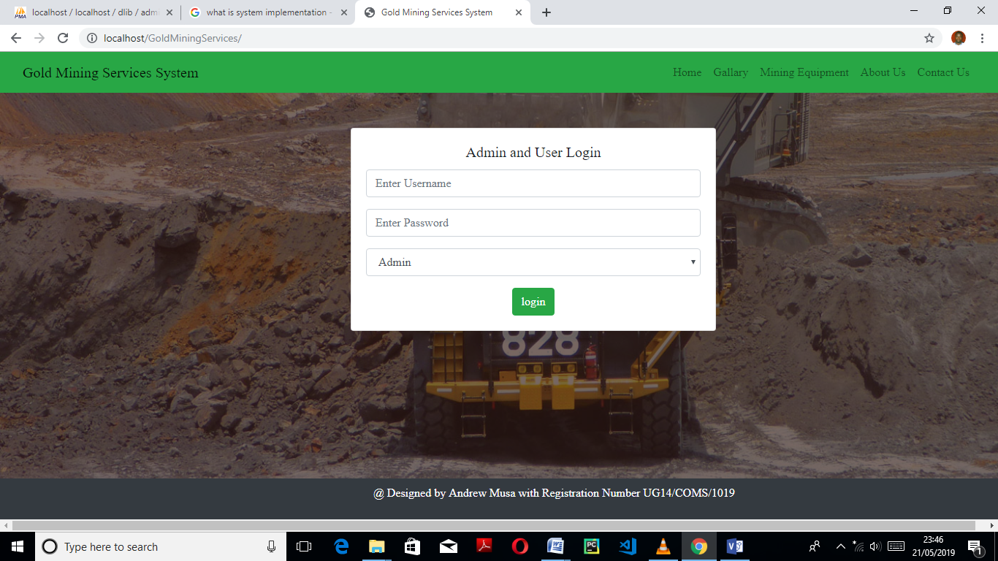

**4.1.2 EMPLOYEE REGISTRATION**

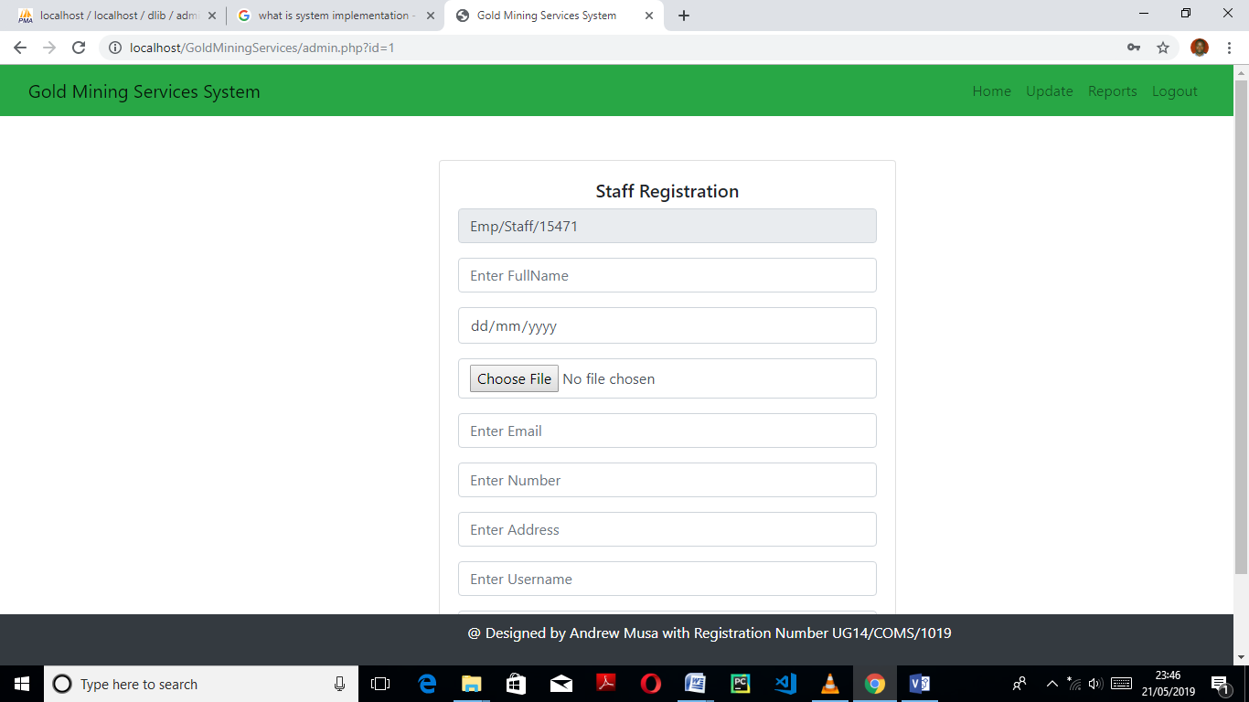

**4.1.3 UPDATE ADMIN RECORD**

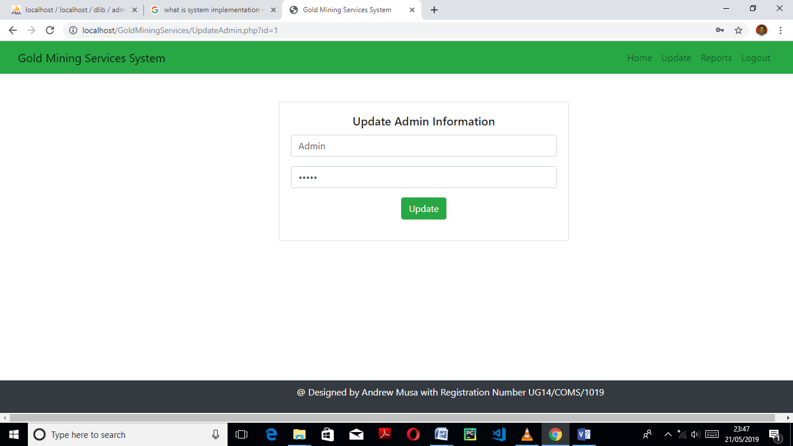

**4.1.4 CLIENT REGISTRATION FORM**

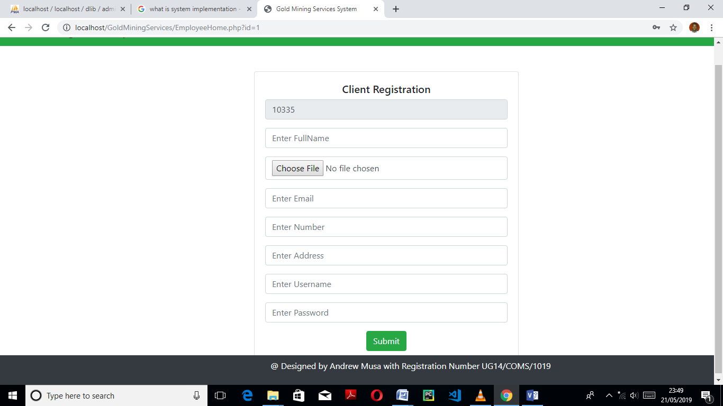

**4.1.5 REGISTER CLIENT FOR PROJECT**

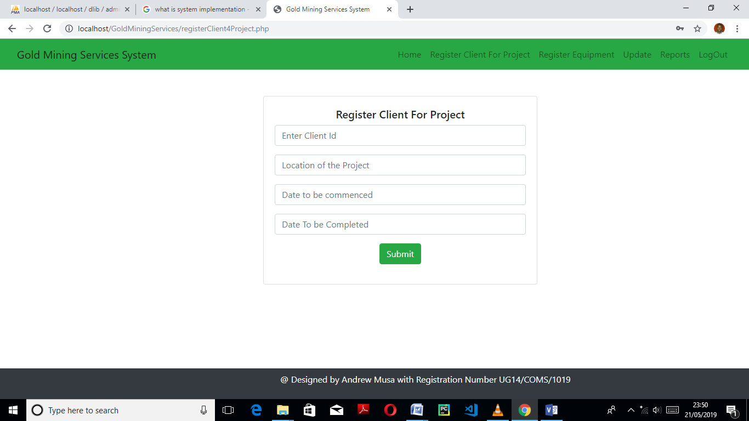

**4.1.6 EQUIPMENT REGISTRATION**

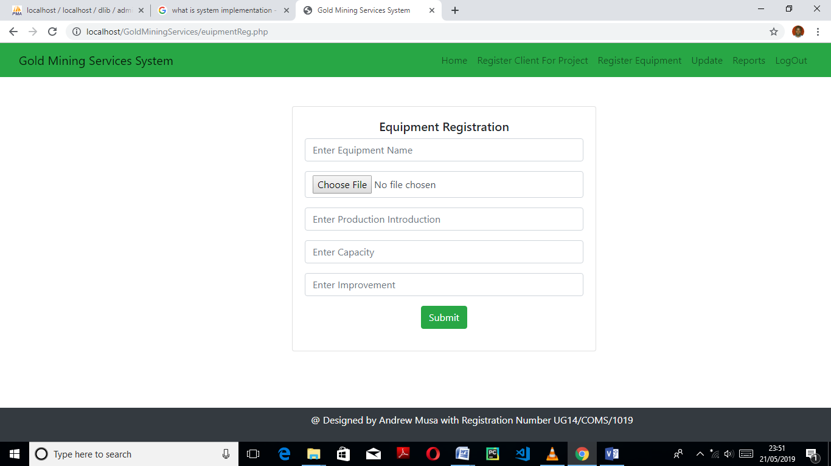

**4.1.7 EMPLOYEE REPORT HOME**

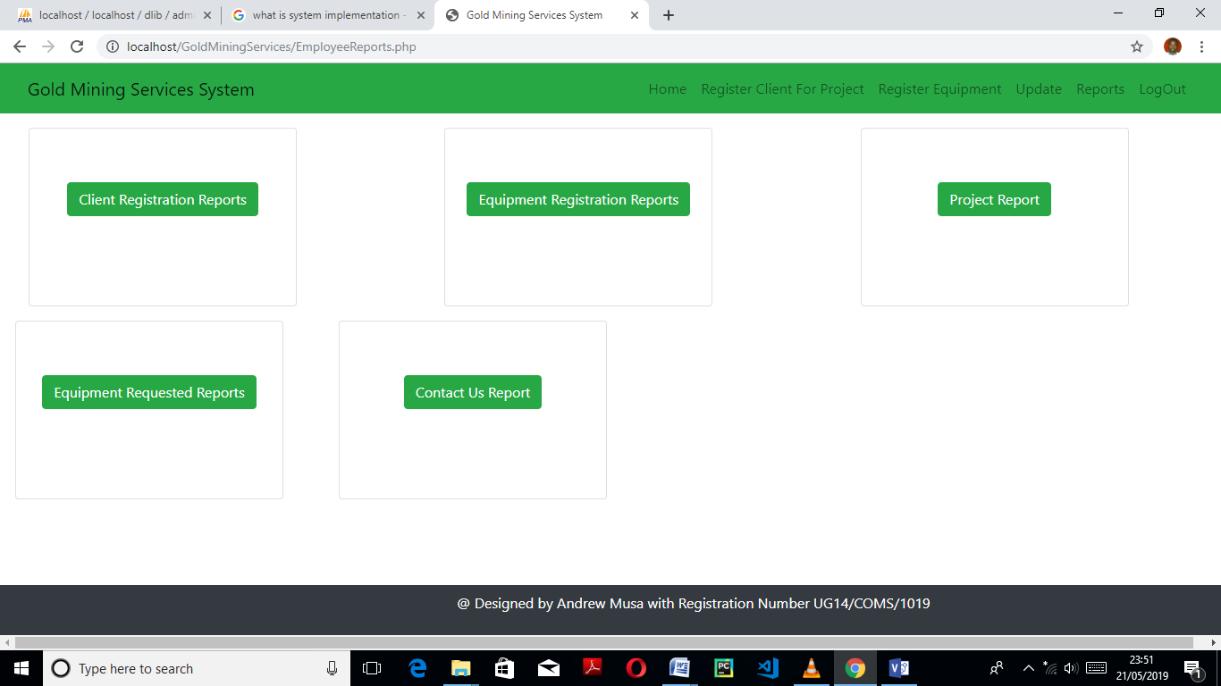

**4.1.8 UPDATE EMPLOYEE INFORMATION**

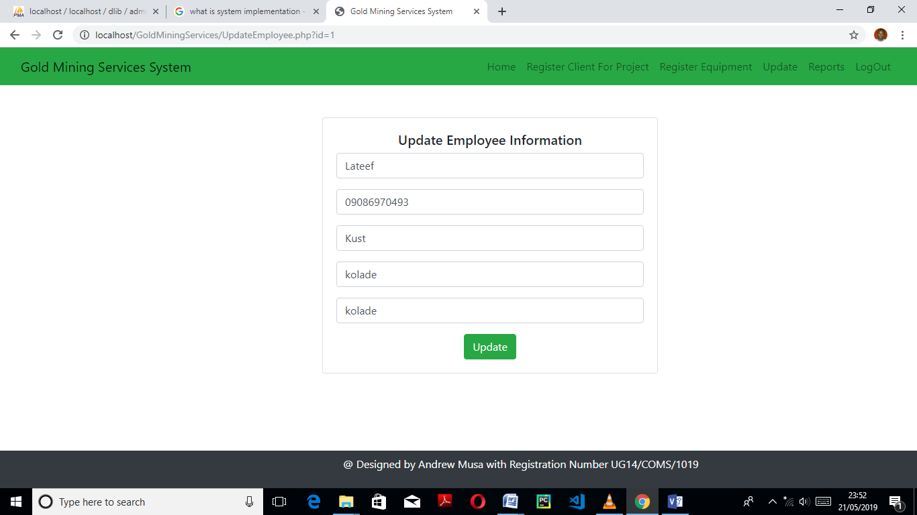

**4.1.9 REGISTERED CLIENT REPORT**

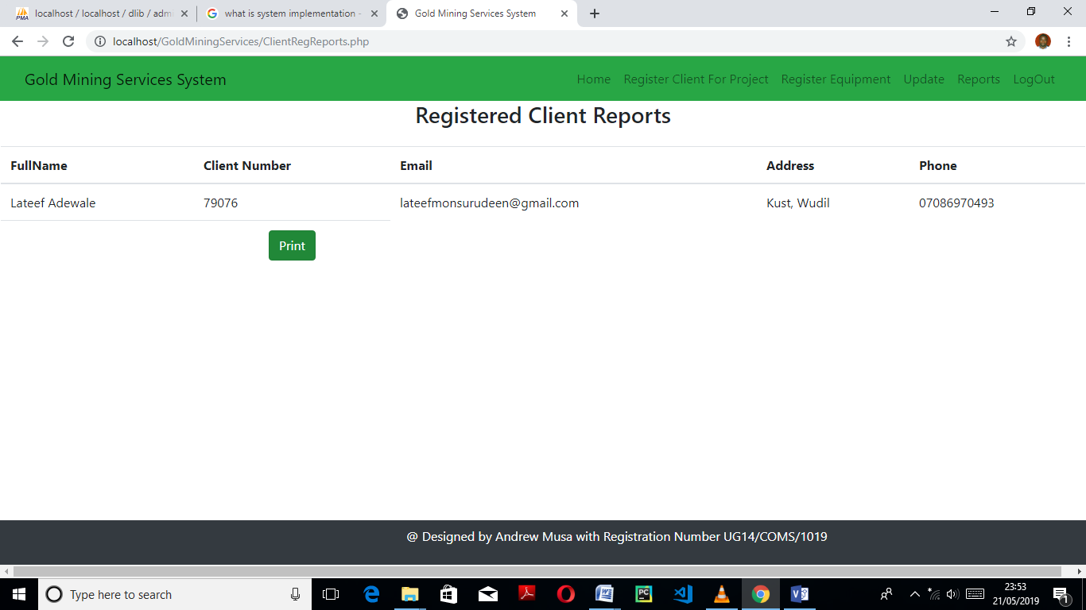

**4.1.10 EQUIPMENT REGISTERED REPORT**

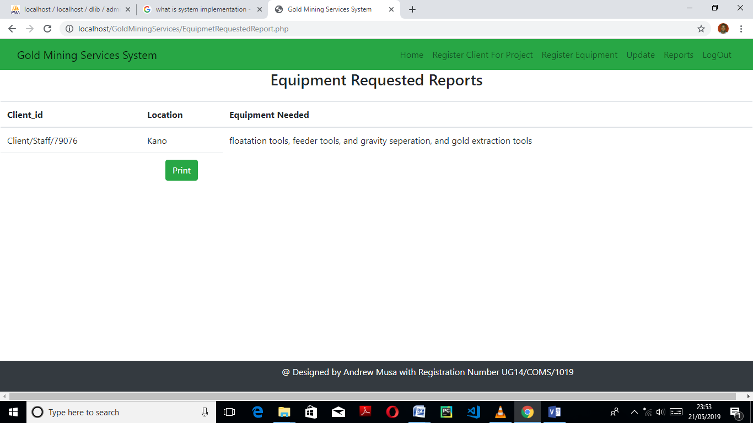

**4.1.11 REQUESTING FOR EQUIPMENT**

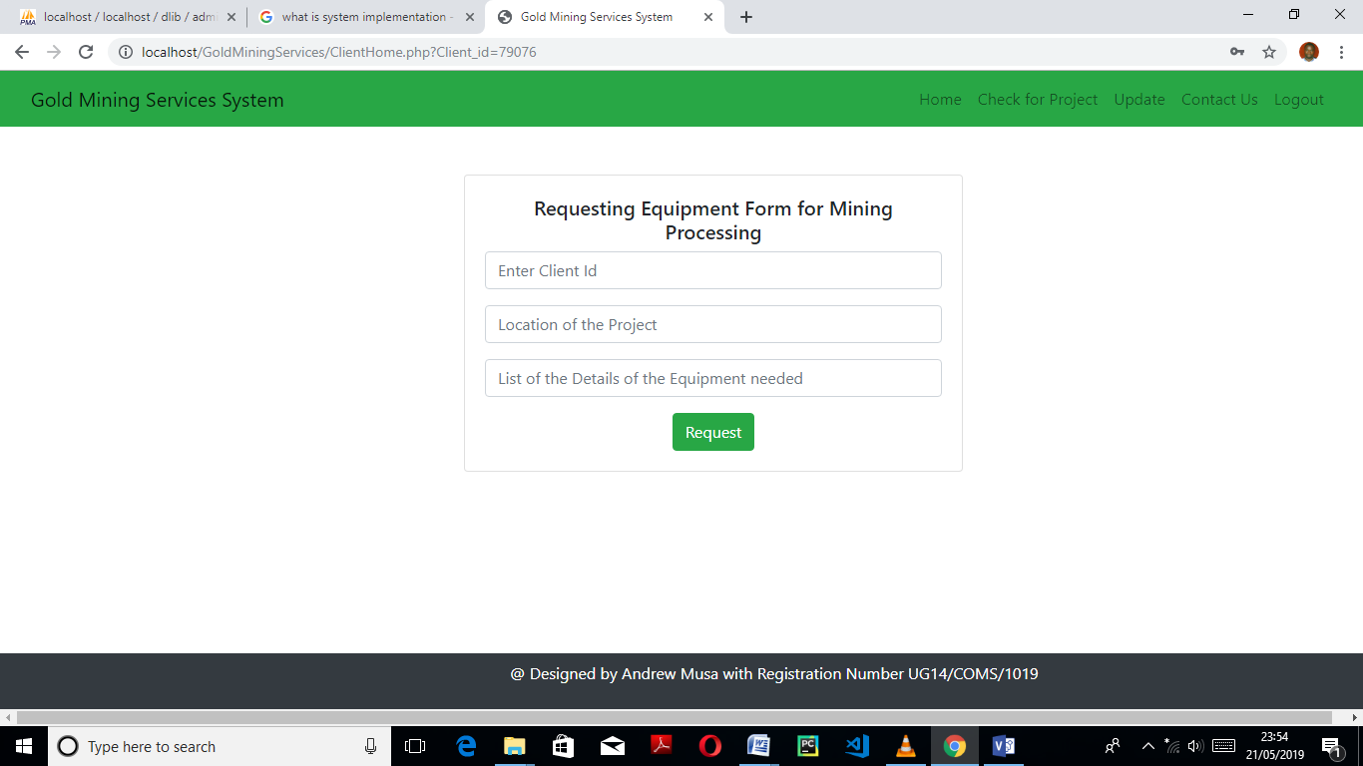

**4.1.12 UPDATE CLIENT INFORMATION CLIENT**

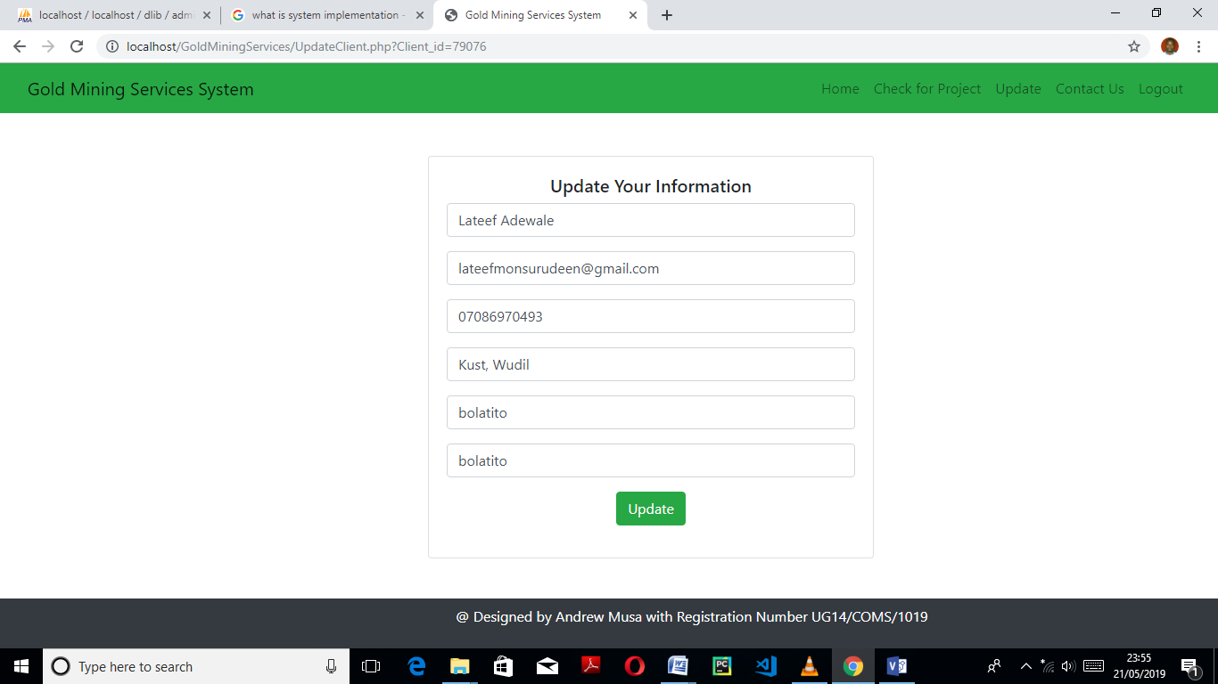

**4.1.13 GALLERY PAGE**

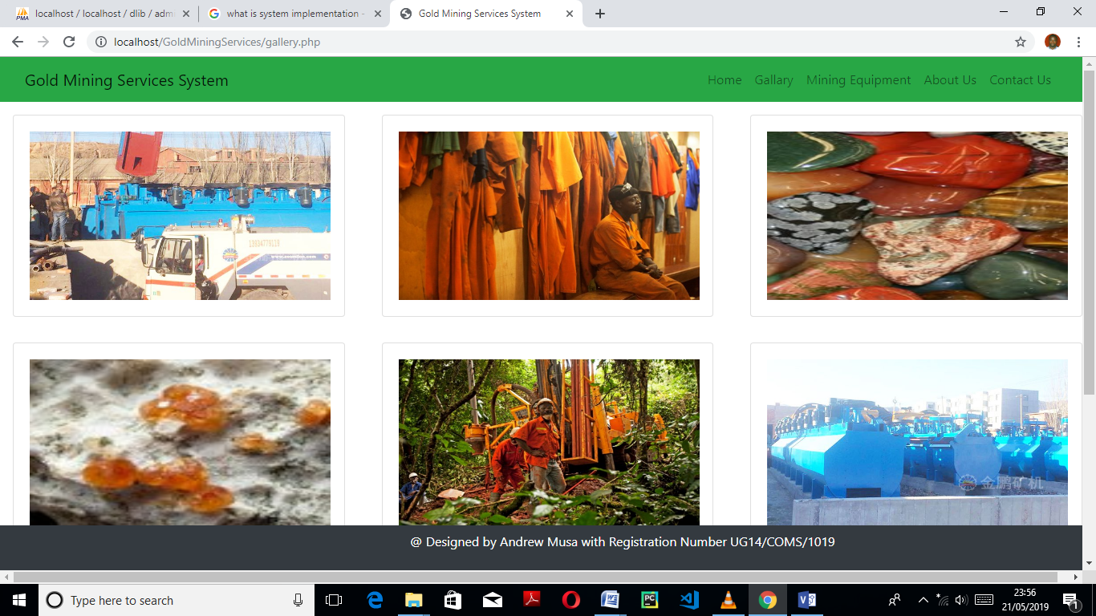

**4.1.14 CONTACT US PAGE**

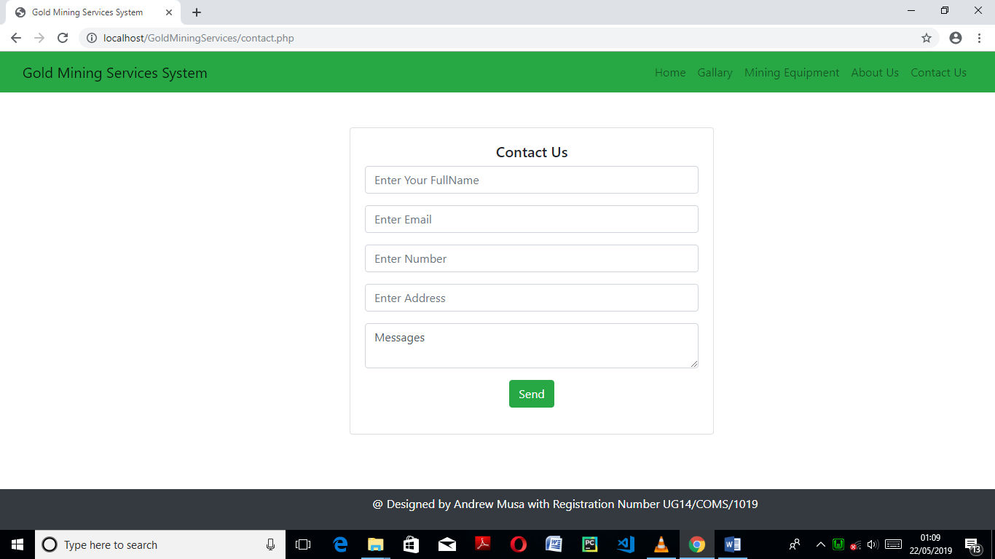

**4.2 SYSTEM TESTING**

System Testing is a black box testing technique performed to evaluate the complete system the system's compliance against specified requirements. In System testing, the functionalities of the system are tested from an end-to-end perspective.

System Testing is usually carried out by a team that is independent of the development team in

order to measure the quality of the system unbiased. It includes both functional and Non-

Functional testing.

Testing is broadly divided into two types on the basis of their activity

* Verification
* Validation

**Verification:** In verification testing software application is not actually executed but the documents or code is checked statically to find out defects. Software development is based on the customer requirement so the software application needs to confirm to the predefined requirement specification.

As the software development goes through different phases it is necessary to ensure that deliverable of each phase is as per the specification Verification makes sure that the software application is getting developed in the correct way with respect to requirement. Verification focuses on find defects as early as possible. It means “Are we doing the right job”. Verification is also known as Static Testing Verification process ends before validation process starts.

**Verification process** During verification all the outcomes of software development including code are read and reviewed by one or more responsible team members to find defect in them. Verification activity are conducted for the deliverables of development phases on left arm of v model Following are the different document on which verification is done to find out defects.

Software requirements specification

* It contains user requirements which are checked in verification activity. It provides acceptance test plan which is use in Acceptance testing.
* High level design document
* High level design document involves software specification. It provides system test plan which are used during system testing.
* Detailed design document

Detailed design involves unit test plan. Unit test plan is use to conduct unit testing.

* Code

Code is also checked statically to find out defects.

**Methods of Verification** Walkthrough and reviews are two methods of verification which are used to stop the incrementing defects in next phases so they are used to reduce the amount of rework.

**Walkthrough:** Walkthrough is an informal process with the intent of providing information and receiving improvements. During walkthrough meeting author describes the document to all the participants of the meeting and then knowledge/doubts is shared. Walkthrough is carried out in following ways. Author explains the product. Participants come out with defects and suggestion Author provides clarification. Suggestions are noted and correction action is taken.

**Reviews** Review is formal process which is used to conduct verification activity It is used to find out defects in formalized manner. Customer, Management, Peer and Audit team are involved in review activity Testers are also involved in requirement reviews Following are the stages of the review process. -Read the documents and check the code -Find out defects -Document it -Close the defect by taking corrective action -Confirm closure of the defect through review.

**Validation:** Validation approach is use to evaluate whether the developed application should functionally do what it is supposed to do and it should satisfy the requirements of the customer. Validation is done by executing the code of the developed functionality Validation is also called as Dynamic testing as validation includes actual execution of the functionality to find out the defects. It focuses on “Are we building the right product” It is represented on the right arm of V model It contains Unit testing, Integration testing, System testing and Acceptance testing.

**Unit testing** Unit testing includes testing of smallest piece of software to verify its behavior. It ensures that the code should satisfy the requirements. It is done by developers. Unit testing is done manually or by using tools also like JUnit, NUnit. It is done to reduce future cost due to early detection of errors. It tests smaller components so that it is easy to find out errors. Enhancement can be performed.

**Integration testing** Integration testing is done to ensure that individually tested components can work together to perform the intended task. Integration testing is important because modules work individually but they may not work together when they are integrated It is used to uncover the problems which are occur in interfaces between different modules. Following approaches are used in Integration testing

* Bottom up approach

In bottom up approach the modules are combined and tested which belong to the bottom of the application hierarchy starting with modules at the top module. When top module is not ready but bottom modules are developed at that time this approach is used. Driver is used in bottom up approach.

* Top down approach

When all the bottom modules are not ready at that time top down approach is used. Stubs are used in top down approach. Stub is a special purpose program which is written to test the integration between modules.

* Critical Part First approach

In this approach critical parts of the system are implemented and tested first. When focusing on entire application is not possible due to time constraint then Functionality which is important is concentrated first.

* Big bang approach

Big bang approach is a common approach in which all modules are integrated at once. No stub and drivers are required in this approach. But it is difficult to debug the code and find out the location of the defect.

**System testing** System testing is conducted to check that the system meets its functional and non-functional requirements System testing is done after integration testing. It is conducted on a complete, integrated system to evaluate the system specified features. It is done by a tester. When all modules are in integrated state and working as a single application at that time system testing is done. Performance testing, Security testing, Confignation testing and Installation testing are done during system testing.

**User Acceptance testing** User Acceptance testing is a final testing before the system is accepted for its intended use. It is based on requirement document. UA testing validates both functional as well as non-functional specifications. UA testing is done according to user requirement to confirm that application is behaving as expected by the customer. It is usually done by customer or end user. There are two types of UA testing -Alpha testing -Beta testing Alpha testing It is done after system testing. It is done at the developer site by a customer. It is performed in a controlled environment Beta testing It is done after alpha testing In beta testing developer is not present at the location. It is conducted at customer site by an end user.

**Non-Functional Testing:** These type of testing are carried out during system testing. Aim is to test the software under different condition.

**Usability testing** Usability testing is done to check the ease of use an application Usability testing determines how it is easy for a new user to carry out basic tasks of an application.

**Load Testing** A load testing is conducted to understand the behavior of the system under a specific load which is mentioned in requirement document.

**Volume testing** Volume testing refers to testing an application with a huge amount of data and checks its limitation.

**Stress Testing** Stress testing is use to determine the ability of an application to maintain a certain level of performance under unfavorable condition.

**Performance Testing** Performance testing tests how well an application behaves with respect to performance requirements.

**Configuration testing** Configuration testing is done to check how application behaves on the range of hardware and software configurations for which it is designed.

**Compatibility Testing** It is done to test the application for the configuration for which it is not designed and check its compatibility. It includes testing of an application on different platforms.

**Security testing** Security testing is done to determine that an application protects data and maintains functionality access as intended.

**SUMMARY**

In Software testing there are different types of testing which are done for different purpose so that quality product is developed. The main objective behind this is to develop error free software. Adequate verification will lead to less issues being present during the validation phase as most of issues are already discovered and corrected during verification and Adequate validation will ensure that software application is developed is as per software artifacts finalized in verification. Therefore, it is important to know all the testing activities as Validation and Verification process goes hand in hand and they reduce the future rework and cost.